Annual Subscription Process for the period of Thermal Year 2018/2019 to Thermal Year 2027/2028 inclusive
Rules for the Annual Subscription Process of Available Regasification Capacity in accordance with Article 8.7 of the Resolution of the Regulatory Authority for Energy, Networks and Environment No 168/06 and Article 2.4.2 a) of Chapter II of the Regasification Code.
Terminale GNL Adriatico S.r.l. (the “Operator" or "Adriatic LNG") publishes the terms and deadlines for the Annual Subscription Process of Available Regasification Capacity in accordance with Article 2.4.2 a) of Chapter II of the Regasification Code.
1) Adriatic LNG makes available for subscription the following Available Capacity for the period of Thermal Year 2018/2019 to Thermal Year 2027/2028 inclusive:
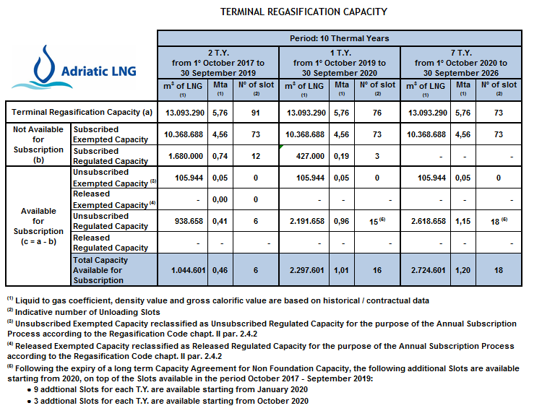

With regard to the dates associated to the available Unloading Slots, we inform you that:

- There are 6 available Unloading Slots during the Thermal Year 2018/2018, with:

  - 1 Slot, 27 – 30 October 2018 *

The remaining 5 Slots for the Thermal Year 2018/2019 will be available in the period January - September 2019 and, the interested User will propose the specific months for the planning of the Unloading Slots in the appropriate table in the Capacity Contract, attached to the Access Request (see below). The Unloading Slots need to be evenly distributed throughout the year. The planning of the Slots will be determined based on estimates of Chapter II, Section 3.2 - Annual Scheduling of the Regasification Code.

* According to the 2018 Annual Plan - Ref. Regasification Code Chapter II, par 3.2.

- For the Thermal Year 2019/2020 to Thermal Year 2027/2028 inclusive:

The interested User will propose the specific months for the planning of the Unloading Slots in the appropriate table in the Capacity Contract attached to the Access Request (see below). The Unloading Slots need to be evenly distributed throughout the year. The planning of the Slots will be determined based on estimates of Chapter II, Section 3.2 - Annual Scheduling of the Regasification Code.

2) The Tariff the Operator will apply is the tariff for the continuous regasification service for the relevant period of allocated capacity as published on the Adriatic LNG website in the Section “Tariffs” of the relevant period in the area: http://www.adriaticlng.it/en/commercial-area/rates/regasification

The Tariff will be defined by the Operator in respect to the maximum tariff approved by the Regulatory Authority for Energy, Networks and Environment.

For reference, see the following publication on the regasification tariff in force from January 1st 2018 to December 31st 2018: http://www.adriaticlng.it/en/commercial-area/rates/regasification
Moreover, other charges will be applied in accordance with the Regasification Code.

3) Access Requests should be sent to Adriatic LNG by registered mail or be hand delivered no later than 17:00 C.E.T. of 2nd (second) July 2018 at the following address:
Terminale GNL Adriatico S.r.l
Piazza S. Freud 1
20154 Milano (MI), Italy
Annual Capacity Subscription Procedure
Att. The Coordinators for Capacity Subscription Ing. Riccardo Dahm Gazzola / Dr.ssa Roberta Pirotta

In the case of hand delivery the Operator will issue a delivery receipt in the following format

To simplify and standardize access requests attached are:

- the form to be used for submitting requests for capacity allocation:

- the form of the Capacity Agreement:

4) Any application for capacity shall be binding, irrevocable and unconditional until 23:59.00 CET of 31st (thirty first) of July 2018.

5) Not later than the 11th of July 2018, the Operator will issue, with respect to each Access Request, an Acceptance, a Modified Acceptance, an Interim Notice or Notice of Rejection as the case may be, in accordance with the provisions of the Regasification Code.
6) The contents of the Access Request, the Subscription Allocation Criteria and the Access Conditions are described in the applicable regulation and in the Regasification Code, in particular in the articles 2.4.5 and 2.4.6 of Chapter II and articles 10.1 of Chapter III.
7) The Regasification Code approved by the Regulatory Authority for Energy, Networks and Environment with the Resolution Arg/Gas 57/11 will regulate the relationship between the parties and is available at the following link: http://www.adriaticlng.it/en/commercial-area/regasification
For the purposes of this publication, the terms above in capital letter will have the meaning as per the Regasification Code, with the provision that the terms defined in the singular are considered to be referred also to the plural and vice versa.
8) The provisions of this publication are an integral and substantial part of the capacity offer under the Annual Subscription process. Copies of the publication, in the form attached, must be signed by the legal representative of the Applicant and be delivered in conjunction with the Access Request.

-- o O o ---

